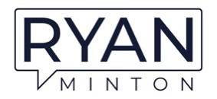

Ryan Minton Partial Client List
Marriott
Hilton
IHOP
The Maids
Lee’s Famous Recipe Chicken
Pink Zebra Moving
IAAPA – The Global Association for the Attractions Industry
Jaguar
Land Rover
Ohio Hotel & Lodging Association
New York State Restaurant Association
New York State Hospitality & Tourism Association
Renaissance Hotels
IHG
CCW – Customer Contact Week

