

**Franchise Testimonials Supporting Vince Poscente’s Keynote Presentations**

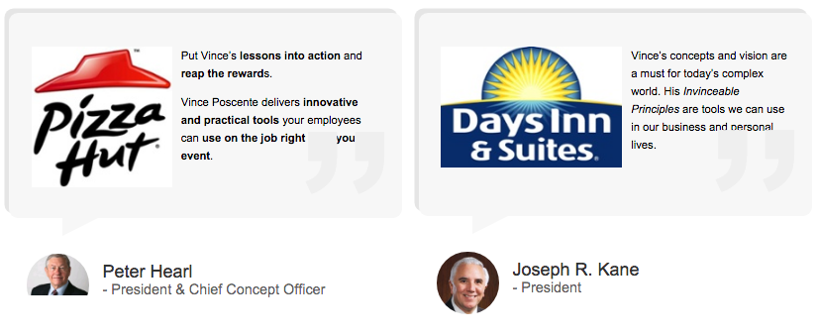

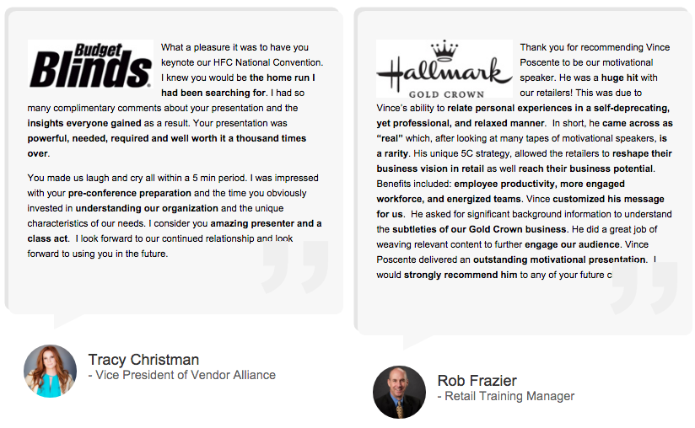

**More Franchise Testimonials for Vince Poscente’s Keynote Presentations**

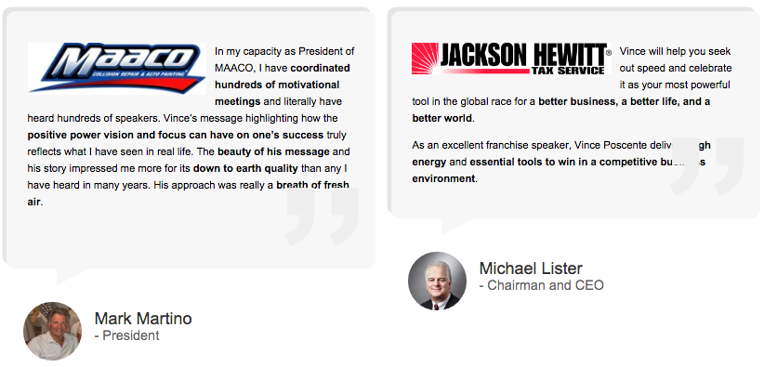

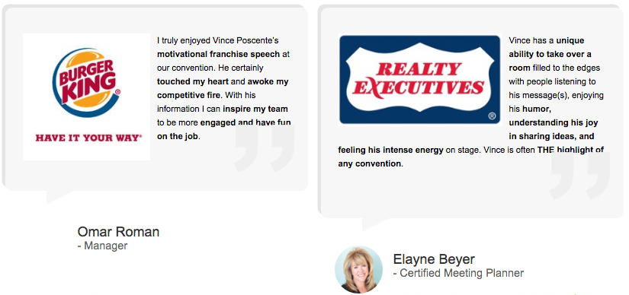

**Franchises Who Have Successfully Booked Vince Poscente for their Conferences:**



**Other Organizations Who’ve Booked Vince Poscente as their Keynote Speaker**







