

facebook.com/DanThurmonFanPage

linkedin.com/in/danthurmon

[www.danthurmon.com](http://www.danthurmon.com/)

instagram.com/officialdanthurmon

youtube.com/danthurmon

twitter.com/DanThurmon

ABOUT DAN THURMON

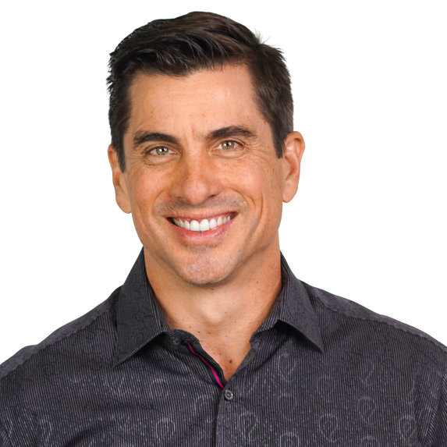

**DAN THURMON, CSP, CPAE**

[info@franchisespeakers.com](mailto:info@franchisespeakers.com) (720) 304-3710

Travels from Atlanta, GA

Dan Thurmon is an author, researcher, and peak performance coach with expertise in work-life integration and change leadership. Also a renowned speaker, Dan has delivered thousands of presentations across six continents for audiences including world leaders, Fortune 500 companies, entrepreneurs, educators, and even troops on the front lines.

Dan is a leader in his profession, having served as President of the National Speakers Association. He is one of less than three hundred people on the planet inducted into the prestigious Speakers Hall of Fame.

Dan is the author of the books Off Balance On Purpose and Positive Chaos, and he produces an ongoing, weekly video-coaching series which is filmed around the world.

Dan is a health and fitness advocate. His hobbies include hot yoga, disc golf, and mountain unicycling. Dan is unique in his approach that incorporates physical stunts and demonstrations into his live presentations.